2007 JRAHS Trial Extension 2

Question 1 |  |  | Marks
(a) (i) |  | Find the real numbers a, b and c such that 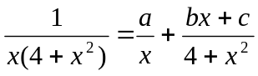. | 2
(ii) |  | Find 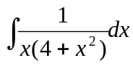. | 2
(b) |  | Evaluate 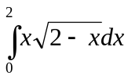, leaving your answer in exact form. | 3
(c) |  | Find the zeros of 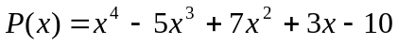 over the complex field if 2 – i is a zero. | 3
(d) |  | Given that I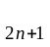=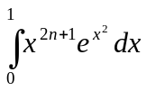 where n is a positive integer, show that  I = 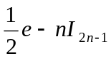. | 2
 |  | Hence, or otherwise, evaluate 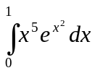. | 3
Question 2 (15 Marks)  Marks

(a)(i)) |  | Given that z= - 3 - 4i, find z. | 4
(ii) |  | Solve the equation 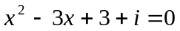over the complex field. | 3
(b) |  | 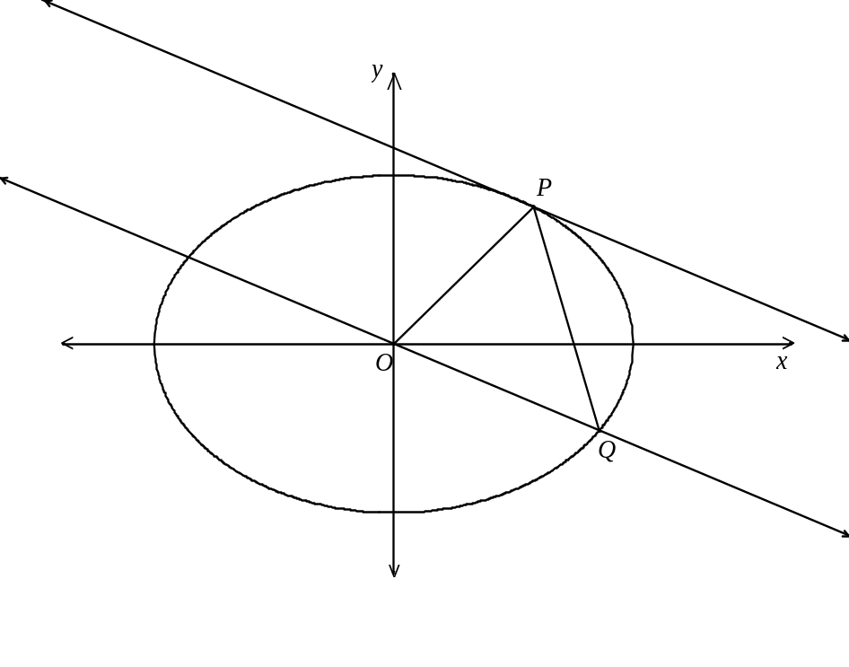
In the diagram above, P(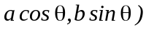is a point on the ellipse 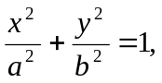 where P lies in the first quadrant.

A straight line through the origin parallel to the tangent at P meets the ellipse at the point Q, where P and Q both lie on the same side of the y-axis.

(i) |  | Prove that the equation of the line OQ is 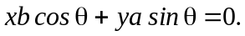 | 2
(ii) |  | Find the coordinates of the point Q given that Q lies in the fourth quadrant. | 3
(iii) |  | Prove that the area of OPQ is independent of the position of P. | 3
Question 3 (15 Marks) 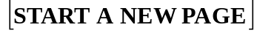 |  |  | Marks
(a) |  | A particle is projected from the origin with a speed V and an angle of elevation on level ground. | 3
A vertical wall of “unlimited” height is a distance d from the origin, and the plane of the wall is perpendicular to the plane of the particle’s trajectory.

If d <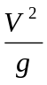, show that the particle will strike the wall before it hits the ground provided that <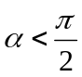 - where = 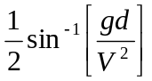.

You may assume that the range on the horizontal plane from the point of projection is 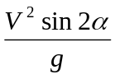 .

(b) |  | Express 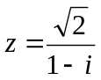 in the modulus-argument form and hence find 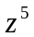 in the form of 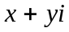. | 4
(c) |  | Question 3 continues on page 4  Question 3 cont’d  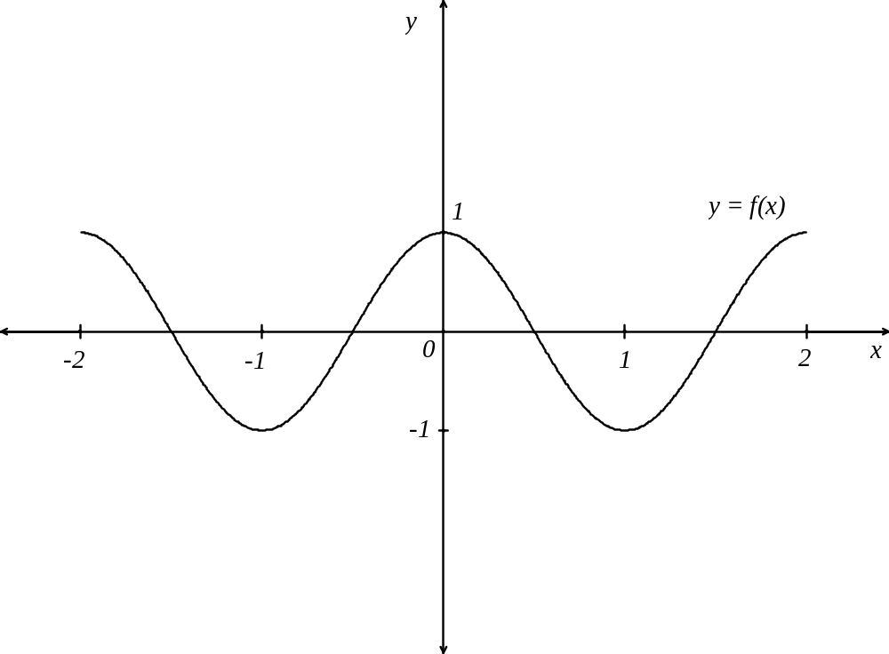 | Marks
The diagram shows the graph of the continuous function 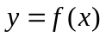. Critical points occur at x = -2, -1, 0, 1, 2.

On the sheets provided draw separate sketches of the graphs of the following :

(i) |  | 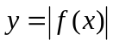 | 1
(ii) |  | 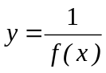 | 2
(iii) |  | 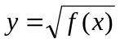 | 2
(iv) |  | 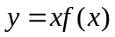 | 3
 |  | Question 4 (15 Marks) | Marks
(a) |  | Find 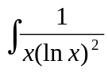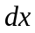. | 2
(b) |  | Five letters are chosen from the letters of the word MOBILITY. These five letters are then placed alongside each other to form a five-letter arrangement.  Find the number of different arrangements which are possible. | 4
(c) |  | P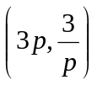 and Q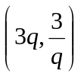are points on different branches of the hyperbola xy = 9.
(i) |  | Find the equation of the tangent at P. | 2
(ii) |  | Find the point of intersection T, of the tangents at P and Q. | 3
(iii) |  | If the chord PQ passes through the point (0, 2), find the locus of T. | 3
(iv) |  | Find the restriction on the locus of T. | 1
Question 5 (15 Marks)

(a) (i) | Find the volume generated when the area bounded by 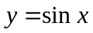 and the x-axis,  for 0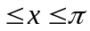, is rotated about the x-axis. |  | 3
(ii) | The area described in (i) is now rotated about the line x = 2.  Find the volume of the solid formed. |  | 4
(b) | Question 5 continues on page 6  Question 5 con’td  A boat showroom is built on level ground. The length of the showroom is 100m. At one end of the showroom the shape is a square measuring 20m by 20m and at the other end an isosceles triangle of height 20m and base 10m. |  | Marks
 | 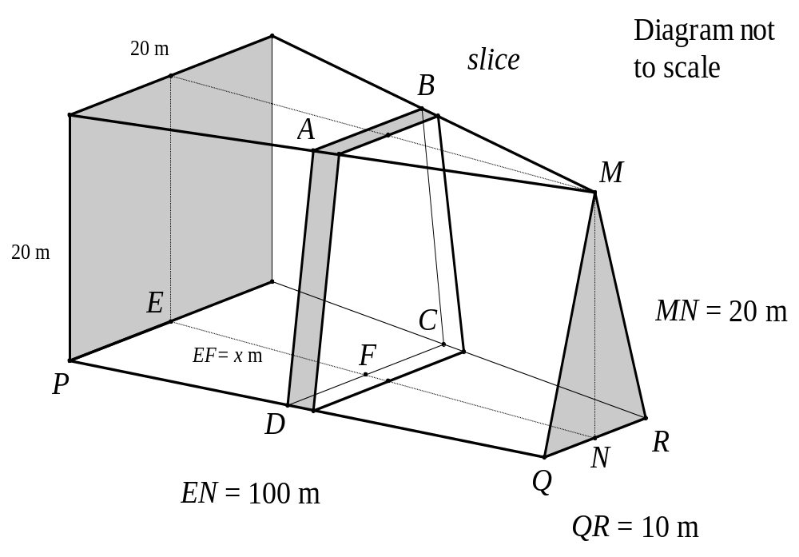
(i) | If EF is x m in length, show that the length of DC is 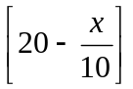m. |  | 2
(ii) | By considering trapezoidal slices parallel to the ends of the showroom, find the volume enclosed by the showroom in m. |  | 6
Question 6 (15 Marks) |  |  | Marks
(a) | Find 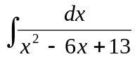. |  | 2
(b) | A food parcel of 1 kg is dropped from a helicopter which is hovering 800 metres above a group of stranded bushwalkers. After 10 seconds a parachute opens automatically. Air resistance is neglected for the first 10 seconds but the effect of the open parachute is to cause a retardation of 2v newtons where v msis the velocity of the parcel after t seconds (t 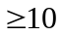).  Take the position of the helicopter as the origin, the downwards direction as positive and the value of g, the acceleration due to gravity as 10m s .
(i)  (ii)  (iii)  (iv)  (v)  (vi) | Write down the equation of motion of the parcel before the parachute opens.  Determine the velocity and the distance fallen by the parcel at the end of the 10 seconds.  Write down the equation of motion for t.  What is the terminal velocity of the parcel?  Show that the velocity of the parcel after the parachute has opened is given by :  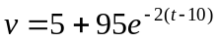, t .  Find the distance fallen, x, as a function of t and hence find the distance the parcel has fallen 1 minute after it leaves the helicopter. |  | 1  4  1  1  3  3
Question 7 (15 Marks) |  |  | Marks
(a) | 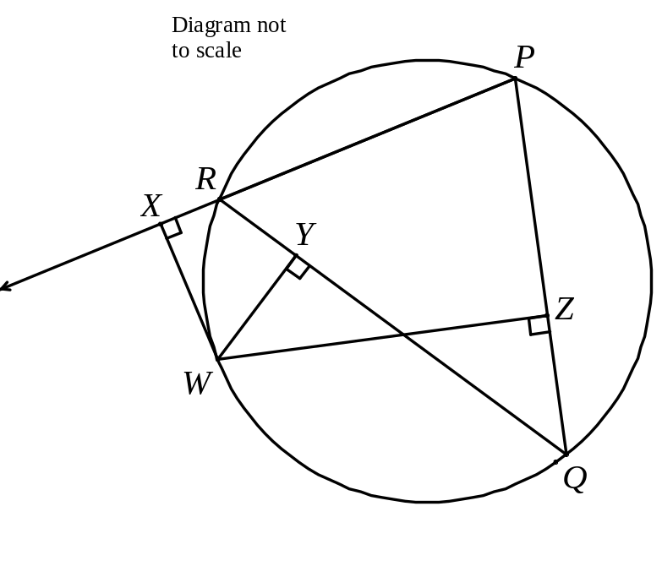
PQR is a triangle inscribed in a circle. W is a point on the arc QR.
From W, perpendiculars are drawn to PR (produced), QR and PQ, meeting them at X, Y and Z respectively.

Copy the diagram.

(i) | Explain why WXRY and WYZQ are cyclic quadrilaterals. |  | 2
(ii) | Prove that the points X,Y and Z are collinear. |  | 4
(b)(i) | By considering the expansion of (cos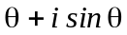) and by using De Moivre’s Theorem show that  cos5. |  | 2
(ii) | Hence finds all the four roots of the equation  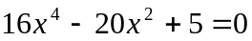. |  | 2
(iii) | Hence or otherwise, show that 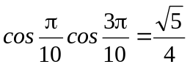. |  | 3
(iv) | Find the exact value of sin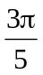sin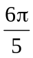. |  | 2
Question 8 (15 Marks) |  |  | Marks
(a) | The region R in the Argand diagram is defined by:  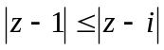 and 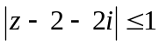.
(i) | Sketch the region R. |  | 3
(ii) | If z describes the boundary of the region R, find  (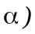 the value of 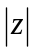 when arg(z) has the smallest value. |  | 2
 | (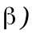 z in the form of a+ib when arg(z-1) = 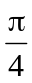. |  | 3
(b) | A certain type of merry go-round consists of seats hung from pivots attached to the rim of a horizontal circular disc. The disc is rotated by a motor attached to the vertical axle. As the angular velocity increases, the seats swing out and move up. The seat is represented by a point with mass m kg suspended by a rod of length h metres below the pivot, which is a metres from the axle of rotation.  Neglecting the mass of the rod, assume that when the disc rotates with constant angular velocity w radians per second, there is an equilibrium position such that the rod makes an angle with the vertical as shown in the diagram on the following page.  Question 8 continues on page 10  Question 8 cont’d  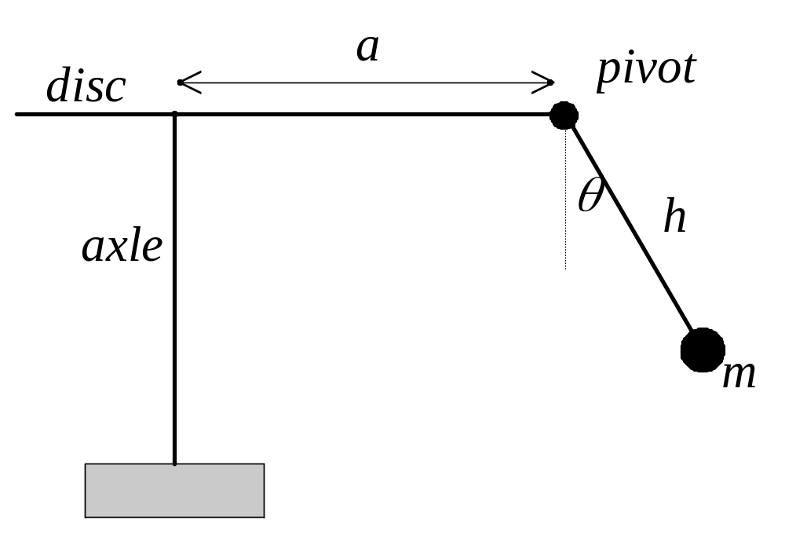  Diagram not to scale |  | Marks
(i) | Show that w and satisfy the equation  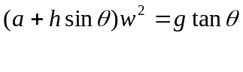  where g is the acceleration due to gravity. |  | 3
(ii) | Use graphical methods to show that for a given w, there is only one value of in the domain 0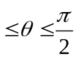, which satisfies the above equation. |  | 3
(iii) | Given a = 4, h = 2.5, = 30 and using g = 10ms, find the angular velocity w correct to 3 significant figures when the merry-go-round is in equilibrium. |  | 1
 | END

